**Registering as an LSC employee with Revenue**

You will need to update the Revenue website [myAccount](https://www.ros.ie/myaccount-web/sign_in.html?execution=e3s1) that your new employer is LSC. If you have not registered for [myAccount](https://www.ros.ie/myaccount-web/sign_in.html?execution=e3s1) you can do it [**HERE**](https://www.ros.ie/myaccount-web/register.html?execution=e1s1).

Once you have logged on to [myAccount](https://www.ros.ie/myaccount-web/sign_in.html?execution=e3s1) you should click on the ‘Update job or pension’ details section.

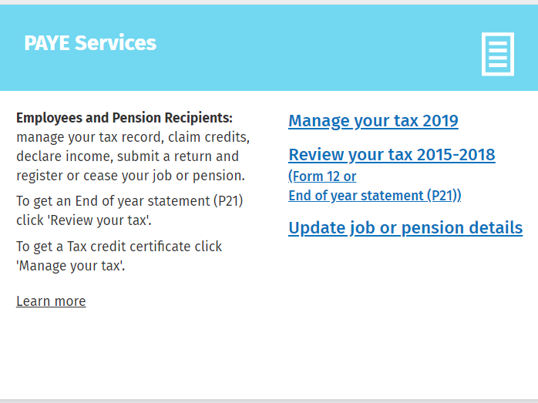

The information you will need to register your new job with LSC is as follows:

* LSC employer number – 6380332D
* Your start date
* Pay frequency is monthly
* Estimate of your overall income for the year
* If you have recently moved to Ireland, you will need to provide some additional details such as arrival date.

It is important that you review your tax credits and cut off to ensure they are correct based on your personal circumstances. This can be review by clicking on ‘Manage your tax’. If you have queries following this review you can contact the Revenue on +353 (01) 738 36 36 and they will discuss your query and resolve it.

Revenue will send the details of your tax credits and cut off to the LSC payroll department electronically and they are uploaded directly to the payroll software.

If you do not register your employment with LSC as per the steps above you will be on emergency tax until you do. LSC are not able to submit tax credits and cut off on your behalf as this information must be received from Revenue electronically.